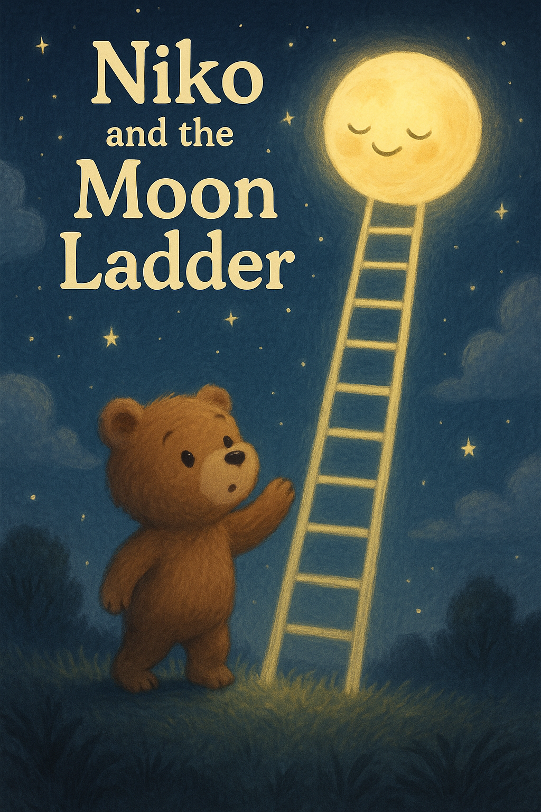

Niko was a little bear who loved looking at the moon. Every night, he wished he could climb up and touch it.

One starry night, he found something strange in his backyard, a tall silver ladder reaching all the way to the sky!

With a deep breath, Niko climbed step by step, past the trees, past the clouds, higher and higher.

When he reached the top, the moon was waiting for him, glowing like a big, warm smile.

The moon gave Niko a soft glowing pebble. “A gift for a brave little bear” it said.

Niko danced with the stars and even gave a sleepy hug to a cloud drifting by.

As the moon whispered, “Come back any time,” the ladder carried Niko home, where he cuddled the glowing pebble, knowing a piece of the moon now lived in his heart.

The End.